Procedure: Identification of Helicobacter pylori in Gastric Biopsy Specimens Using

PyloriTek® Rapid Urease Test Kit

Prepared by | Date Adopted | Supersedes Procedure #

Review Date |  | Revision Date | Signature

Distributed to | # of Copies | Distributed to | # of Copies

PRINCIPLE:

The PyloriTek® Test Kit detects urease activity in gastric biopsy specimens for the presumptive identification of Helicobacter pylori organisms. This organism produces high levels of an enzyme called urease, which is not present in mammalian tissue.¹ If urease is present in the gastric biopsy, it reacts with urea in the Substrate Pad of the PyloriTek Reagent Strip to generate ammonia. A pH indicator in the PyloriTek Reaction Pad turns from yellow to an intense purple/blue color when ammonia is detected.

Over 90% of patients with duodenal ulcer and about 80% of those with gastric ulcer have been reported to have H. pylori infection.² Eradication of H. pylori has proven effective in eliminating or reducing recurrence of gastric and duodenal ulcers.^{3,4}
SPECIMEN:

Patient Preparation:
The current medical consensus is that the patient refrain from taking antibiotics and/or bismuth for 14-28 days prior to the gastroscopy procedure. Proton pump inhibitors should also be avoided for seven to fourteen days prior to the procedure. [Note: The gastroenterology unit may wish to change these guidelines based on the judgement of their staff physicians.] These drugs have been shown to reduce urease activity of H. pylori and to reduce the density and number of organisms, thereby increasing the chance of a false negative test result.

Type:
Gastric specimen. Only one biopsy is required, however up to three biopsies from one patient can be placed on the Reaction Pad of one PyloriTek Reagent Strip.
The area to be biopsied and the number of biopsies is determined by the doctor, but areas commonly biopsied are the greater curvature of the pre-pyloric antrum, the antral lesser curvature near the incisura and the greater curvature of body of the stomach .^{5,6} Avoid areas of erosion or ulceration.

Handling Conditions:
The gastric biopsy must be transferred directly from the forceps to the Reaction Pad of the PyloriTek Reagent Strip in a timely manner to minimize loss of urease activity in infected specimens. Use a wooden applicator stick or plastic pick to transfer the biopsy to the Reaction Pad. Do not place the gastric biopsies on gauze or filter paper prior to placing it on the Reaction Pad. Mucous containing H. pylori organisms may inadvertently be transferred to the gauze and increase the chance of a false negative result.⁷
Avoid contamination of biopsy specimens with formalin from biopsy forceps, work surfaces or other sources. Formalin can inhibit H. pylori urease activity and lead to false negative test results.

EQUIPMENT AND MATERIALS:
Equipment:
Gastroscope
Forceps: Bard® Precisor™ Forceps or other suitable biopsy forceps
Materials:
Supplied with the PyloriTek Test Kit:
Reagent Strips
Hydration Reagent
Disposable Reaction Pouches
Also needed:
Pencil or marker
Timer – 1 minute increments up to 60 minutes
Wooden applicator stick or plastic pick
PyloriTek Quick Reference Guide

The diagrams contained in this document are only intended as a schematic representation of reacted PyloriTek Reagent Strips. Please refer to the“PyloriTek Quick Reference Guide” for a visual guide to interpreting reaction patterns.

Preparation:

- If the doctor determines that a rapid urease test is necessary, make sure all the components of the PyloriTek Test Kit are on hand and at room temperature; one bottle of PyloriTek Reagent Strips, one bottle of Hydration Reagent and Disposable Pouches equivalent to the number of reagent strips in the kit..
- Check the expiration dates on the PyloriTek Reagent Strips and Hydration Reagent to make sure they have not expired.
- Immediately prior to use, remove one PyloriTek Reagent Strip from the bottle.
- Do not touch the white pads on the back of the Reagent Strip, but make sure the Positive Control Spot (small red dot) is visible in the upper left-hand corner of the Reaction Pad. (Refer to Diagram 1A.)
- Place the strip on a clean, dry surface with the white pads and Positive Control Spot facing down (in preparation for writing the patient’s name).
- Replace the cap on the bottle and tighten securely.

PyloriTek Reagent Strip


Unreacted Positive Control Spot
Back view Front view
Diagram 1A Diagram 1B

Performance Parameters:
PyloriTek is a simple threshold test designed to detect an active H. pylori infection in gastric biopsy specimens. In several major studies, the average specificity was reported as 95% (range 94% - 97%) and the average sensitivity as 97% (range 94% - 99%).⁸⁻¹⁴
Storage Requirements:
- Store the PyloriTek Test Kit in the refrigerator at 2°- 7°C (36°- 45°F) until the kit is to be used.
- Always allow the kit components to come to room temperature prior to opening and use.
- Once the bottle has been opened, store all kit components at room temperature 15-30°C (59°- 86° F).
- PyloriTek Reagent Strips must be used within 3 months of first opening the bottle or before the kit expiration date, whichever occurs first.
- Do not remove a PyloriTek strip from the bottle until immediately before use.
- Replace the bottle cap immediately and tightly after removing a strip.
- Do not remove the desiccant pack.
QUALITY CONTROL:

External controls
Serim offers an external positive control for PyloriTek (request Product Code 5146 – PyloriTek Positive Control Papers). This reactive control contains urease (the same enzyme produced by H. pylori bacteria) and mimics the result of an H. pylori-infected gastric biopsy. Use of this control will assist in monitoring the testing process, from biopsy application to result interpretation, to assure proper test performance

Internal Controls
A positive and negative control is incorporated into each PyloriTek Reagent Strip. No additional preparation is required and controls are “automatically” run every time a reagent strip is used. These procedural controls verify that the Hydration Reagent was added and that test system is working as expected.

Internal Positive Control
An unreacted Positive Control appears as a red spot located on the Reaction Pad in the upper left-hand corner. (Refer to Diagram 2.) The red spot contains urease and acts as an integral reactive Positive Control meaning that the control spot actually contains the target analyte (urease). This spot also serves as a process control; its development indicates that all the steps of the test procedure have been performed properly.

Unreacted Positive Control

(Back view)
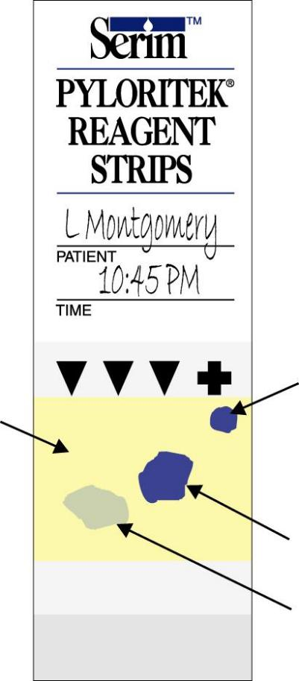
Reacted Positive & Negative Controls
(Front view)
Unreacted Positive Control
Spot
Reacted Positive Control
Negative Control Area
Positive Specimen
Negative Specimen

Diagram 2 Diagram 3

Corrective Actions
- If the red Positive Control Spot is not visible on the back of the PyloriTek Reagent Strip
- Do not use the strip.
- Obtain another reagent strip to perform the H. pylori test.
- Retain the strip with the missing Positive Control Spot and contact your PyloriTek Sales Representative.
- If the Positive Control does not develop by the full 60 minute development time
- The test is invalid and the results should not be reported.
- The biopsy(ies) may be transferred once to a second PyloriTek Reagent Strip for repeat testing. This decision should be made by the attending physician based on the patient’s history, symptoms and observations during endoscopy.
- An alternative method is to place the biopsy(ies) in formalin and send it to pathology for histological staining and pathological interpretation.
- Retain the strip with the atypical Negative Control and contact your PyloriTek Sales Representative.

Internal Negative Control
Viewed from the front of the PyloriTek Reagent Strip, any area of the yellow Reaction Pad other than directly above the Positive Control Spot or a gastric biopsy can be chosen to serve as a Negative Control area. (Refer to Diagram 3.) This is a procedural control; maintenance of a creamy yellow or yellowish-orange color in this area during the entire 60-minute development time indicates that the integrity of the Reagent Strip has been maintained. To assist the user in proper interpretation of positive and negative results, a visual interpretation chart is available from the PyloriTek Sales Representative.

Corrective Actions
- If the unreacted yellow Reaction Pad displays an atypical color prior to use:
- Do not use the strip.
- Obtain another reagent strip to perform the H. pylori test.
- Retain the strip with the atypical color and contact your the PyloriTek Sales representative.
- If the yellow Negative Control area of the Reaction Pad displays an atypical color during the 60 minute development time (refer to Diagrams 4A & B):
- The test is invalid and the results should not be reported.
- An alternative method is to place the biopsy(ies) in formalin and send it to pathology for histological staining and pathological interpretation.
- Retain the strip with the atypical color and contact your PyloriTek Sales & Services Representative.

Failed Negative Controls
(Color in areas other than above a gastric specimen or Positive Control Spot)

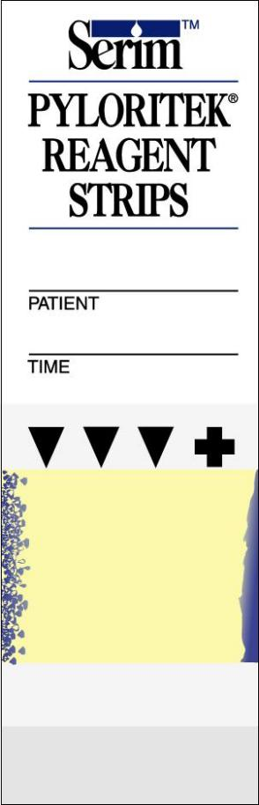

Front of strip

Diagram 4A Diagram 4B

Should the controls for any strip react incorrectly, the test is invalid and the results should not be reported.

PROCEDURE - STEPWISE:

- Write the patient’s name or I.D. number and the time the test is started on the front of the PyloriTek Reagent Strip.
- Turn the strip over. Crease the strip at the perforation (pads facing in); then add 4 drops of Hydration Reagent to each quadrant of the Substrate Pad (adjacent to the 4 printed droplets. See Diagram 2).
- Place up to 3 biopsies, properly spaced, from the same patient on the Reaction Pad. Do not place the biopsy on or very near the red control spot.
- Fold the Substrate Pad over onto the Reaction Pad and insert the strip into the Disposable Pouch.
- Set a timer for 60 minutes, but check the strip periodically.
- Interpret the results of the test at 60 minutes. A positive result may be evident before the 60 minutes has expired. However, a full 60 minutes is needed to confirm a negative result.
Interpretation:
Sixty minutes after inserting the PyloriTek Reagent Strip into the Disposable Pouch, interpret the results of the test by observing the area of the Reaction Pad over the gastric biopsy for color development and comparing it to the Positive Control. The Reaction Pad should also be observed to assure that the Negative Control areas remained yellow. Disregard any color formed more than 60 minutes after insertion of the strip into the Disposable Pouch.

Positive If the Negative Control areas remain yellow, and the Positive Control Spot in the upper right-hand corner displays an intense purple/blue color and a similar color has developed over the gastric biopsy within 60 minutes of starting the test, the result is reported as “Positive”; the biopsy is infected with H. pylori. Occasionally, the color over a positive biopsy may not develop as a dense, unbroken shape like the Positive Control, but appear stippled containing intense purple/blue irregular-shaped spots.

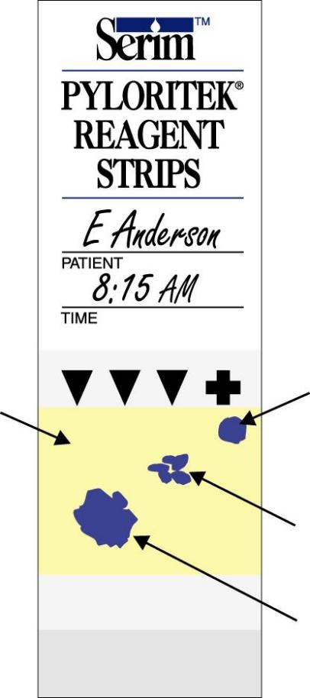
Positive Control
Negative Control Area
Positive Specimen (stippled)
Positive Specimen

Diagram 5

Occasionally, the patient’s specimen may yield a positive reaction before the control spot develops. In these cases, wait the full 60 minutes for the Positive Control Spot to develop before interpreting the final test results. Occasionally, a dark blue stippled pattern (see Diagram 5) may appear over the biopsy. This should be interpreted as a positive result. Positive results can be interpreted any time up to 60 minutes if an intense purple/blue color appears over both the biopsy specimen and the Positive Control Spot and the Negative Control areas remain yellow.

Negative If, 60 minutes after starting the test, the Negative Control areas remain yellow, and the Positive Control Spot in the upper right-hand corner displays an intense purple/blue color, but there is no color or only a pale blue or faint gray color over the gastric biopsy, the result is reported as “Negative”; the biopsy is not infected with H. pylori. Occasionally a pale blue or gray color will appear over an uninfected gastric biopsy. This result should be interpreted as Negative.

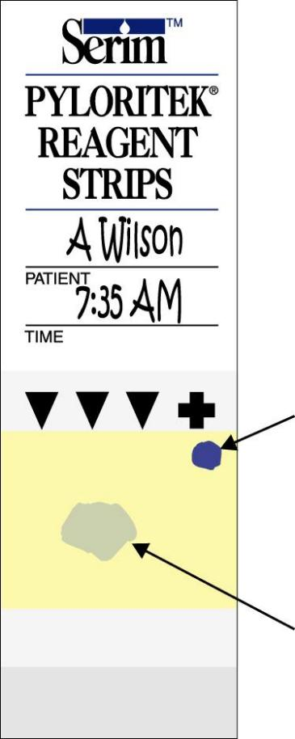
Positive Control
Negative Specimen

Diagram 6

Should the controls for any strip react incorrectly, the test is invalid and the results should not be reported. Disregard color formed more than 60 minutes after insertion of the strip into the Disposable Reaction Pouch.

Refer to the “PyloriTek Quick Reference Guide” for a visual guide to interpreting reaction patterns.
(Available from your PyloriTek Representative or from Serim.)

REPORTING RESULTS:
Reporting Format:

PyloriTek test results are reported as Positive or Negative for an H. pylori infection.
The following is a suggested form for reporting the results of the PyloriTek Test:

PyloriTek Test Results for: |  | (Patient ID) |  |  | (Date)
Areas to interpret  on the PyloriTek Reagent Strip ↓ | Description of Normal Appearance ↓ |  | Actual Results (check one):
Areas to interpret  on the PyloriTek Reagent Strip ↓ |  |  | Normal Appearance | Abnormal Appearance |  | Comments
Positive Control Spot | Intense purple/blue color in upper right-hand corner of the yellow Reaction Pad
Negative Control Areas | Reaction Pad remains yellow in areas  other than above the Positive Control  or an infected gastric biopsy.
 |  |  | Positive | Negative |  | Comments
Biopsy #1
Biopsy #2
Biopsy #3
PROCEDURE NOTES:
- Always check the expiration dates on PyloriTek Reagent Strips and Hydration Reagent before use.
- Allow all kit components to come to room temperature prior to opening the kit and prior to use. This prevents condensation from forming inside the bottle of PyloriTek Reagent Strips.
- Make sure the red control spot is present on the Reaction Pad before using the strip.
- Do not lay the strip on a wet counter.
- Do not handle the strip with wet gloved hands as the Positive Control Spot could be smeared or rubbed off.
- Do not use a strip if the Reaction Pad displays atypical purple, blue or gray areas prior to use. (Some strips may have a “mottled” yellow-orange Reaction Pad, but this slight variation in color is normal and it does not affect performance of the PyloriTek Reagent Strip.)
- Make sure the Hydration Reagent is added to the Substrate Pad. Place 1 drop of Hydration Reagent on each quadrant of the Substrate Pad.
- Do not add more or less than 4 drops of Hydration Reagent; just enough to be sure the Substrate Pad is thoroughly and evenly moistened before folding/closing the strip.
- After moistening the Substrate Pad, do not repeatedly fold and unfold the strip. If more than 1 biopsy is to be placed on the strip, do not fold the strip until the last biopsy is in place.
- Place the biopsy on the Reagent Strip as soon as possible after retrieval so that urease activity in the biopsy is not lost.
- Applicator sticks or plastic picks can be used to transfer the biopsy from the forceps to the Reagent Strip. Avoid using needles to prevent inadvertent needle sticks.
- Use only the Disposable Reaction Pouch supplied in the kit to hold the folded PyloriTek Reagent Strip.
- Insert the PyloriTek Reagent Strip into the Disposable Pouch until the strip touches the bottom of the pouch. Do not use tape or paper clips to hold the PyloriTek Reagent Strip closed.
- The patient’s specimen may yield a positive reaction before the control spot develops. In these cases, wait until the Positive Control Spot develops (allow the full 60 minutes if necessary) before interpreting the final test results.
- If the controls on a particular strip do not react properly, retain the bottle of remaining strips for return to the PyloriTek Sales Representative.

LIMITATIONS OF THE PROCEDURE:

PyloriTek Reagent Strips detect ammonia generated by H. pylori urease-catalyzed hydrolysis of urea in the Substrate Pad. Ammonia can also be produced by tissue autolysis or can be found in blood as a waste product. However, these non-specific reactions usually occur at a slower rate than can be detected visually in 60 minutes by the PyloriTek Test Kit. It is possible that abnormal increases in these reactions may give a false positive result.

False negative results may occur if the area biopsied has not been colonized by H. pylori or if the patient has been on antibiotic and/or bismuth salt therapy.

A positive test does not distinguish between asymptomatic colonization and a symptomatic infection.

The PyloriTek Test Kit is to be used as an aid in diagnosis only for those patients with clinical symptoms of H. pylori infection.

REFERENCES:

- Delluva AM, Markley K, Davies RE. The absence of gastric urease in germ free animals. (1968) Biochem. Biophys. Acta, 151: 646-50.
- Peterson WL, Helicobacter Pylori and Peptic Ulcer Disease, (1991) New Eng. J. Med., 324: 1043-48.
- Marshall BJ, Goodwin CS, Warren JR, et al. Prospective double blind trial of duodenal ulcer relapse after eradication of Campylobacter pylori. (1988) Lancet 2: 1437-42.
- Hentschel E, Brandstätter G, Dragosics B, et al. Effect of Ranitidine and Amoxicillin plus Metronidazole on the eradication of Helicobacter pylori and the recurrence of duodenal ulcers, (1993) New Eng. J. Med., 328: 308-12.
- Genta RM and Graham DY. Comparison of biopsy sites for the histopathologic diagnosis of H. pylori: a topographic study of H. Pylori density and distribution. (1994) Gastrointestinal Endoscopy, 40:342-5.
- El-Zimaity HMT, Al-Assi MT, Genta RM, Graham DY. Confirmation of Successful Therapy of Helicobacter pylori Infection: Number and Site of Biopsies for a Rapid Urease Test. Am J Gastroenterol 1995; 90(11): 1962-1964.
- Yokoi T, Yoshikane H, Hamijama E, Nakamura S, Asia J, Ito M. Evaluation of Handling Methods in the Histological Diagnosis of Helicobacter pylori: The Effect of Filter Paper. Am J Gastroenterol 1996; 91(11): 2344-46.
- Rogge JD, Wagner DR, Carrico RJ, Glowinski EA, Mahoney SJ, Boguslaski RC, Genta RM. Evaluation of a New Urease Reagent Strip for Detection of Helicobacter pylori in Gastric Biopsy Specimens. Am J Gastroenterol 1995; 90:1965-68.
- Young EL, Sharma TK, Cutler, AF. Prospective evaluation of a new urea-membrane test for the detection of Helicobacter pylori in gastric antral tissue. Gastrointestinal Endoscopy 1996; 44: 527-31.
- Yousfi MM, El-Zimaity HMT, Genta RM, Graham DY. Evaluation of a new reagent strip rapid urease test for detection of Helicobacter pylori infection. Gastrointestinal Endoscopy 1996; 44:519-22.
- Laine L, Lewin D, Naritoku W, Estrada R, Cohen H. Prospective comparison of commercially available rapid urease tests for the diagnosis of Helicobacter pylori. Gastrointestinal Endoscopy 1996; 44:523-26.
- Puetz T, Vakil N, Phadnis S, Dunn B, Robinson J. The PyloriTek Test and the CLO Test: Accuracy and Incremental Cost Analysis. Am J Gastroenterol 1997; 92(2): 254-57.
- Elitsur Y, Hill I, Lichtman S, Rosenberg A. Prospective Comparison of Rapid Urease Tests (PyloriTek, CLO Test) for the Diagnosis of Helicobacter pylori Infection in Symptomatic Children: A Pediatric Multicenter Study. Am J Gastroenterol 1998; 93(2): 217-19.
- Murata H, Kawano S, Tsuji S, Tsujii M, Sawaoka H, Iijima H, Kawai N, Hori M. Evaluation of the PyloriTek Test for Detection of Helicobacter pylori Infection in Cases With and Without Eradication Therapy. Am J Gastroenterol 1998; 93(11): 2102-05.

